|  |  |  |  |
| --- | --- | --- | --- |
| To: | **[Enter Manager Name here]**  Hub Manager  UNHRD **[Enter Hub Name here]** | Date: 27 December 2024 | |
| From: | **[Enter Head of Operations or Warehouse manager Name here]**,  UNHRD **[Enter Hub Name here]** | |  |

|  |  |
| --- | --- |
| Subject: | Adjustment of unreconciled **[Enter “WFP” or “WFP and ”NOWFP” here]** Stock in UNHRD **[Enter Hub Name here]** after **[Enter Month and Year here]** Physical Inventory |

**Background**

The Physical Count of all stock held by **[Enter “WFP” or “NOWFP” here]** users in UNHRD **[Enter Hub Name here]** was conducted between **[Enter range of dates here]** in accordance with UNHRD SOPs. During the Physical Count the below discrepancies were noted.

**[Insert here the printshot of the list of adjustments and eventual reconciliations: open the “Historical Physical Inventory report” and click on “FILTER FOR MEMO” button to show only the lines with comments]**

**EXAMPLE**

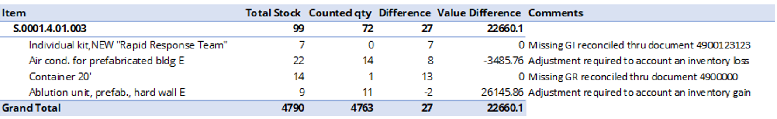

The above discrepancies were subject to re-counts and crossed checked by UNHRD **[Enter Logistics Officer or Warehouse manager as title here]**.

Following extensive system and physical checks the above items were still not located.

**Recommendations**

With the present Note for the Record, the Logistics unit presents to UNHRD **[Enter hub name here]** Management the financial adjustments required to clear the unreconciled stock from WMS.

**[Enter hub manager name here]** Approved o

UNHRD **[Enter hub name here]** Not approved o